**DIRECT BUYING AND SELLING AGRICULTURAL PRODUCTS**

Submitted to

Kongunadu Arts and Science College (Autonomous)

Affiliated to Bharathiar University in partial fulfillment of the requirements for the award of the degree of

***Bachelor of Computer Applications***

Submitted by

**S. Kaviyarasan**

**Reg. No :191CA224**

Under the guidance of

**Mrs.A.Immaculate B.Sc.,** **MCA., M.Phil.,** **Ph. D.,**



**Department of Computer Applications**

Kongunadu Arts and Science College (Autonomous)

Re-accredited by NAAC with A+ Grade (4th Cycle)

College of Excellence (UGC)

Coimbatore – 641 029.

JUNE - 2022

**DECLARATION**

I declare that the Project work entitled **“DIRECT BUYING AND SELLING AGRICULTURAL PRODUCTS”** submitted to Kongunadu Arts and Science College (Autonomous) affiliated to Bharathiar University in partial fulfillment of the requirement for the Degree of Bachelor of Computer Applications is a record of original Project work done by me during the period of study (2019 - 2022), under the Supervision of

**Mrs.A.Immaculate B.Sc., MCA., M.Phil., Ph. D.,** Associate Professor, Department of Computer Applications at Kongunadu Arts and Science College (Autonomous), Coimbatore. The project has not formed the basis for the award of Degree / Diploma /Associate ship/Fellowship or similar title to any candidate of any University.

***------------------------------------***

***Signature of the Candidate***

***G. KAVIAYARASAN***

**Place: Coimbatore**

**Date:**

**Kongunadu Arts and Science College (Autonomous)**

Re-accredited by NAAC with A+ Grade (4th Cycle)

College of Excellence (UGC)

Coimbatore – 641 029.

**CERTIFICATE**

This is to certify that the Project work entitled

**“ATTENDANCE MANAGEMENT SYSTEM”**

is the bonafide work doneby

**G. Kaviayarasan**

**(191CA224)**

Under the Guidance of

**Mrs.A.Immaculate B.Sc., MCA., M.Phil., Ph. D.,**

Associate Professor in Computer Applications

in partial fulfillment of the requirement for the award of the Degree of Bachelor of Computer Applications

------------------------------

Signature of the Guide

Mrs.A. Immaculate B.Sc., MCA., M.Phil., Ph. D.,

Countersigned

Head of the Department Principal

Submitted for Viva – Voce Examination held on ***25.06.2022*** at Kongunadu Arts and Science College (Autonomous), Coimbatore – 641 029.

***INTERNAL EXAMINER EXTERNAL EXAMINER***

**ACKNOWLEDGEMENT**

I am very much grateful to the almighty who has helped me all the way through the project and who has moulded me into what I’ am today.

I wish to express our heartfelt gratitude to our late honourable President Late.

**Dr. M. ARUCHAMI, M.Sc., BT., Ph.D., FAZ., FRES.,** providing all facilities during the course of my study.

I wish to express our heartfelt gratitude to our honourable Secretary and Director **Dr. C.A. VASUKI** providing all facilities during the course of my study.

I really deem it my privilege to convey my thanks to our principal

**Dr. M. LEKESHMANASWAMY M.Sc., M.Phil., Ph.D., B.Ed.,** for providing all the facilities in our college to carry out our project successfully.

I really deem it my privilege to convey my thanks to our Dean Academic

**Dr. S. R. Madhan Shankar, M.Sc., Ph.D.** for providing all the facilities in our college to carry out our project successfully.

I express my sincere thanks to **Dr.A.Indumathi M.Sc., M.Phil., Ph.D.**

Associate Professor and Head(I/c), Department of Computer Applications who had led me in the right path during these years of stay in this campus.

I would like to express our deep sense of gratitude to our guide

**Mrs.A.Immaculate B.Sc., MCA., M.Phil., Ph.D.,** Associate Professor, Department of Computer Applications, for the encouragement and guidance he had given us for the successful completion of this project.I am grateful to her in all the ways.

I also express my heart feel gratitude to all other faculty members, Department of Computer Applications, for their guidance and support throughout my project. I am highly beholden to my parents, my friends for unstained support, persistence, encouragement and co-operation.

|  |  |
| --- | --- |
| Untitled-1 copy | **KONGUNADU ARTS AND SCIENCE COLLEGE**  **(AUTONOMOUS)**  [College of Excellence (UGC)]  Coimbatore – 641 029.  **DEPARTMENT OF COMPUTER APPLICATIONS** |

**Dr. A.Indumathi MCA., M.Phil.,Ph.D.**

***Associate Professor and Head(I/c)***

***Department of Computer Applications***

**TO WHOM SO EVER IT MAY CONCERN**

This is to certify that **G. KAVIAYARASAN, (**Reg. No **191CA224**) BCA final year student of **Kongunadu Arts and Science College (Autonomous),** Coimbatore has successfully completed this Project titled **“DIRECT BUYING AND SELLING AGRICULTURAL PRODUCTS– UNDER GRADUATE”** at our organization from February 2022 to June 2022.

During this project his performance was found to be good. We wish his success in all the future endeavours.

With Regards

**DECLARATION**

I, **G. KAVIYARASAN** declare that the project work entailed **“DIRECT BUYING AND SELLING AGRICULTURAL PRODUCTS”** submitted to Kongunadu Arts and Science College (Autonomous), Coimbatore affiliated to Bharathiyar University, in partial fulfillment of the requirements for the award of the Degree of Bachelor of Computer Applications is a record of original work done by me under the valuable guidance of

**IMMACULATE** Professor in Computer Applications (UG), Kongunadu Arts and Science College (Autonomous), Coimbatore.

Signature of the Candidate

**G. KAVIYARASAN**

**Place: Coimbatore**

**Date:**

**CONTENTS**

**S.NO TITLE PAGE.NO**

1 **INTRODUCTION**

* 1. ORGANIZATION PROFILE
  2. ABOUT THE PROJECT

1. **SYSTEM STUDY**
   1. EXISTING SYSTEM
   2. DISADVANTAGES OF EXISTING SYSTEM
   3. PROPOSED SYSTEM
   4. ADVANTAGES OF PROPOSED SYSTEM
   5. FEASIBILITY STUDY
2. **SYSTEM SPECIFICATION** 
   1. HARDWARE REQUIREMENT
   2. SOFTWARE REQUIREMENT
   3. ABOUT THE SOFTWARE
3. **` SYSTEM DESIGN**
   1. DATA FLOW DIAGRAM
   2. DATABASE DESIGN
   3. INPUT DESIGN
   4. OUTPUT DESIGN
4. **SYSTEM TESTING AND IMPLEMENTATION**
   1. SYSTEM TESTING
   2. SYSTEM IMPLEMENTATION
   3. MAINTENANCE
5. **CONCLUSION**
6. **SCOPE FOR FUTURE ENHANCEMENT**
7. **BIBILOGRAPHY**
8. **APPENDIX**
9. TABLES
10. FORM DESIGN
11. REPORTS

**SYNOPSIS**

Farmer corner is a website which helps buyer to get products directly from the farmer. Farmer can login into the website with a separate login ID’s and passwords. In this website the products are posted by the farmer. The product is posted with full details of its which conveys the state of the product, quantity of products available and the location of the product where it was harvested by the farmer. By posting the pictures and cost of the products the consumer could easily access the farmer. They can also add the production cost of the products and that could be farmers choice. For those farmers who don’t have access to the internet facility could contact through phone call and our team could able to arrange the facilities to them with the help of nearby browsing centers.

In this System, there was no third party to interrupt for buying and selling. This helps both farmer and buyer in many ways. Without the interference of the third-party traders the farmers can reach the buyers directly and sell the products. This is a open source website. Even This System does not charge for the process of helping farmers and buyers. Donation can be done when farmer or buyer gets satisfied by this website.

Buyers can visit the website by logging in website and buy the products trust with the help of checking the quality of the product. When there was no Interference with third party, buyer can get products with low cost than getting it from a third party. The quality of the product also be verified on the current place itself.

1. **INTRODUCTION**

**1.2 ABOUT THE PROJECT**

Direct Buying and Selling Agricultural Products helps in improvement of dealing of buyer and farmer. Farmer corner is a website which helps buyer to get products directly from the farmer. Farmer can login into the website with a separate login ID’s and passwords. In this website the products are posted by the farmer. The product is posted with full details of its which conveys the state of the product, quantity of products available and the location of the product where it was harvested by the farmer. By posting the pictures and cost of the products the consumer could easily access the farmer. They can also add the production cost of the products and that could be farmers choice. For those farmers who don’t have access to the internet facility could contact through phone call and our team could able to arrange the facilities to them with the help of nearby browsing centers.

In this System, there was no third party to interrupt for buying and selling. This helps both farmer and buyer in many ways. Without the interference of the third-party traders the farmers can reach the buyers directly and sell the products. This is an open-source website. Even This System does not charge for the process of helping farmers and buyers. Donation can be done when farmer or buyer gets satisfied by this website.

Buyers can visit the website by logging in website and buy the products trust with the help of checking the quality of the product. When there was no Interference with third party, buyer can get products with low cost than getting it from a third party. The quality of the product also be verified on the current place itself. Buyer has demand of buying products they buy products with large amount in a low cost.

**MODULE DESCRIPTION**

* Farmer login
* User login
* Products
* Feedback

**FARMER LOGIN**

The farmer can register into this website when he/she was new to it. After they can login to the website and post the details of the product, they have with them. The details of the products are mentioned with location, contact details, quality and quantity of the products available.

**USER LOGIN**

The user can register into this website when he/she was new to it. After they can login to the website and can verify the products posted by the farmer. And can buy the product needed. The buyer will be travel to the exact location of the product cultivated or to a common place which was comfort for the both buyer and farmer.

**PRODUCT**

Agricultural products like fruits and vegetables are posted by the farmer. The products are posted with details for the guidance for the buyer. Where buyer verify the product, he/she need to buy.

**FEEDBACK**

The user can review their comments in the feedback form. This helps us to maintain the corrections in the website. This will be stored in user database

**2. SYSTEM STUDY AND ANALYSIS**

**2.1 EXISTING SYSTEM**

There was a website and application named “vidhai”. “vidhai” is a retail-focused store offering food and related consumables produced from organic farming methods and certified organic according to organic farming standards. They are the connections between the farmer and buyer. This is also be like flipkart, amazon but only with organic products. In this system includes door delivery where your products will be in your doorstep.

**2.2 DRAWBACKS OF EXISTING SYSTEM**

* The cost of the product is higher than the cost of product when it was in the hand of farmer.
* It takes time to get the products from the website.
* They include delivery charges when less amount of product bought by user.
* Products can’t be verified and it can only view when order was in hand.
* This includes third party there will be no trust on the product state.

**2.3 PROPOSED SYSTEM**

“FARMER CORNER” is an open-source website. The buyer gets the product from a well know farmer nearby. This system makes more comfortable for the buyers. Here we post only agricultural products like fruits and vegetables. The products are posted with the photos, amount of the product, location of the product and farmer’s contact details. Location of the product Consumer get the products on the spot of the product yielded. From this the farmer can view the state of it and verify the product. He can judge the worth of the product and can be bought with the low cost. If there was an error or some queries, the farmer/user contact the admin with the below mentioned contacts at the end of the home page. This System was most helpful for the farmer and User.

**2.4 ADVANTAGES OF PROPOSED SYSTEM**

* This website doesn’t include third parties interfere.
* The product state can be verified by the user on the location of the product yielded.
* Cost of the product will be decreased for the buyer, when direct purchasing between farmer and buyer.
* Product will be sold little higher amount, which even helps to gain more for farmer.
* By the help of the location included by the farmer, buyer need not to be travelled for long distance for buying products.
* User/Buyer can check the quantity of the product and he/she can satisfy the needy.

**2.5 FEASIBILITY STUDY**

A feasibility study is done to understand if the practicality of a proposed project or system is economically feasible or not.

As the name suggests, a feasibility study is conducted to determine the practicality of an idea or a proposed plan. It is typically conducted before starting any phases of a project. It outlines the market conditions, key project objectives, opportunities, alternative solutions, potential bottlenecks, in a word the chance of the project.

A feasibility study evaluates a project’s chance of success in project management. Therefore, potential investors first check if the study is created from an objective perspective. Here below you can find three basic types of feasibility.

**OPERATIONAL FEASIBILITY**

In Operational Feasibility degree of providing service to requirements is analysed along with how much easy product will be to operate and maintenance after deployment. Along with these other operational scopes are determining usability of product, determining suggested solution by software development team is acceptable or not etc.

**TECHNICAL FEASIBILITY**

In Technical Feasibility current resources both hardware software along with required technology are analysed/assessed to develop project. This technical feasibility study gives report whether there exists correct required resources and technologies which will be used for project development. Along with this, feasibility study also analyses technical skills and capabilities of technical team, existing technology can be used or not, maintenance and up-gradation is easy or not for chosen technology etc.

**ECONOMIC FEASIBILITY**

In Economic Feasibility study cost and benefit of the project is analysed. Means under this feasibility study a detail analysis is carried out what will be cost of the project for development which includes all required cost for final development like hardware and software resource required, design and development cost and operational cost and so on. After that it is analysed whether project will be beneficial in terms of finance for organization or not.

1. **SYSTEM CONFIGURATION**

**3.1 HARDWARE CONFIGURATION**

**Processor : Any processor above 2 GHz**

**Ram : 2 GB**

**Hard Disk : 100 GB**

**3.2 SOFTWARE CONFIGURATION**

**Language : HTML**

**Technologies : CSS, Java Script, Bootstrap**

**Backend : My SQL**

**Web Server : Apache**

**3.3 SOFTWARE FEATUERES**

**HTML (HyperText Markup Language)**

**HTML** stands for HyperText Markup Language. It is used to design web pages using a markup language. HTML is the combination of Hypertext and Markup language. Hypertext defines the link between the web pages. A markup language is used to define the text document within tag which defines the structure of web pages. This language is used to annotate (make notes for the computer) text so that a machine can understand it and manipulate text accordingly. Most markup languages (e.g., HTML) are human-readable. The language uses tags to define what manipulation has to be done on the text.

HTML is a markup language used by the browser to manipulate text, images, and other content, in order to display it in the required format. HTML was created by Tim Berners-Lee in 1991. The first-ever version of HTML was HTML 1.0, but the first standard version was HTML 2.0, published in 1995.

**ADVANTAGE OF HTML**

* HTML is Easy to Learn and Use HTML is very easy to learn and understand.
* HTML is Free One of the biggest advantages of HTML is that it is free of cost and there is no need to purchase specific software.
* HTML is supported by all Browsers Almost all the browsers around the globe are supported by HTML.
* HTML is the Friendliest Search Engine HTML is one of the friendliest search engines in comparison to all the programming languages available in the market (Search Engine).
* HTML is Simple to Edit HTML is very easy to edit as there is no need to have a special interface or platform to edit it.
* HTML can Integrate Easily with Other Languages HTML can be easily integrated with multiple languages and does not create any issues in it.
* HTML is Lightweight HTML is lightweight language. It has a high signal to noise ratio as compared to other forms of communication.
* HTML is Basic of all Programming Languages For the programmer to be either frontend or backend developer, one must have knowledge of HTML as it is the basic language.
* Display Changes Instantly One of the biggest advantages of HTML is that one can see the changes instantly just by saving it and reload the previous HTML page.
* HTML is User-Friendly.

**CSS (Cascading Style Sheet)**

Cascading Style Sheets, fondly referred to as CSS, is a simple design language intended to simplify the process of making web pages presentable.

CSS handles the look and feel part of a web page. Using CSS, you can control the color of the text, the style of fonts, the spacing between paragraphs, how columns are sized and laid out, what background images or colours are used, layout designs, variations in display for different devices and screen sizes as well as a variety of other effects.

CSS is easy to learn and understand but it provides powerful control over the presentation of an HTML document. Most commonly, CSS is combined with the markup languages HTML or XHTML.

**ADVANTAGES OF CSS**

* **CSS saves time** − You can write CSS once and then reuse same sheet in multiple HTML pages. You can define a style for each HTML element and apply it to as many Web pages as you want.
* **Pages load faster** − If you are using CSS, you do not need to write HTML tag attributes every time. Just write one CSS rule of a tag and apply it to all the occurrences of that tag. So, less code means faster download times.
* **Easy maintenance** − To make a global change, simply change the style, and all elements in all the web pages will be updated automatically.
* **Superior styles to HTML** − CSS have a much wider array of attributes than HTML, so you can give a far better look to your HTML page in comparison to HTML attributes.
* **Multiple Device Compatibility** − Style sheets allow content to be optimized for more than one type of device. By using the same HTML document, different versions of a website can be presented for handheld devices such as PDAs and cell phones or for printing.
* **Global web standards** − Now HTML attributes are being deprecated and it is being recommended to use CSS. So, it’s a good idea to start using CSS in all the HTML pages to make them compatible to future browsers.

**JAVASCRIPT**

JavaScript is a dynamic computer programming language. It is lightweight and most commonly used as a part of web pages, whose implementations allow client-side script to interact with the user and make dynamic pages. It is an interpreted programming language with object-oriented capabilities.

JavaScript was first known as **Live Script,** but Netscape changed its name to JavaScript, possibly because of the excitement being generated by Java. JavaScript made its first appearance in Netscape 2.0 in 1995 with the name **Live Script**. The general-purpose core of the language has been embedded in Netscape, Internet Explorer, and other web browsers.

The [ECMA-262 Specification](http://www.ecma-international.org/publications/index.html) defined a standard version of the core JavaScript language.

* JavaScript is a lightweight, interpreted programming language.
* Designed for creating network-centric applications.
* Complementary to and integrated with Java.
* Complementary to and integrated with HTML.
* Open and cross-platform

## CLIENT-SIDE JAVASCRIPT

Client-side JavaScript is the most common form of the language. The script should be included in or referenced by an HTML document for the code to be interpreted by the browser.

It means that a web page need not be a static HTML, but can include programs that interact with the user, control the browser, and dynamically create HTML content.

The JavaScript client-side mechanism provides many advantages over traditional CGI server-side scripts. For example, you might use JavaScript to check if the user has entered a valid e-mail address in a form field.

The JavaScript code is executed when the user submits the form, and only if all the entries are valid, they would be submitted to the Web Server.

JavaScript can be used to trap user-initiated events such as button clicks, link navigation, and other actions that the user initiates explicitly or implicitly.

## ADVANTAGES OF JAVASCRIPT

The merits of using JavaScript are −

* **Less server interaction** − You can validate user input before sending the page off to the server. This saves server traffic, which means less load on your server.
* **Immediate feedback to the visitors** − They don't have to wait for a page reload to see if they have forgotten to enter something.
* **Increased interactivity** − You can create interfaces that react when the user hovers over them with a mouse or activates them via the keyboard.
* **Richer interfaces** − You can use JavaScript to include such items as drag-and-drop components and sliders to give a Rich Interface to your site visitors.

## LIMITATIONS OF JAVASCRIPT

We cannot treat JavaScript as a full-fledged programming language. It lacks the following important features −

* Client-side JavaScript does not allow the reading or writing of files. This has been kept for security reason.
* JavaScript cannot be used for networking applications because there is no such support available.
* JavaScript doesn't have any multi-threading or multiprocessor capabilities.

Once again, JavaScript is a lightweight, interpreted programming language that allows you to build interactivity into otherwise static HTML pages.

## JAVASCRIPT DEVELOPMENT TOOLS

One of major strengths of JavaScript is that it does not require expensive development tools. You can start with a simple text editor such as Notepad. Since it is an interpreted language inside the context of a web browser, you don't even need to buy a compiler.

To make our life simpler, various vendors have come up with very nice JavaScript editing tools. Some of them are listed here −

* **Microsoft FrontPage** − Microsoft has developed a popular HTML editor called FrontPage. FrontPage also provides web developers with a number of JavaScript tools to assist in the creation of interactive websites.
* **Macromedia Dreamweaver MX** − Macromedia Dreamweaver MX is a very popular HTML and JavaScript editor in the professional web development crowd. It provides several handy prebuilt JavaScript components, integrates well with databases, and conforms to new standards such as XHTML and XML.
* **Macromedia Home Site 5** – Home Site 5 is a well-liked HTML and JavaScript editor from Macromedia that can be used to manage personal websites effectively.

**BOOTSTRAP**

Bootstrap is a**free and open-source web development framework**. It’s designed to ease the web development process of responsive, mobile-first websites by providing a collection of syntax for template designs. In other words, Bootstrap helps web developers build websites faster as they don’t need to worry about basic commands and functions. It is the most popular front-end framework in the recent time. It is sleek, intuitive, and powerful mobile first front-end framework for faster and easier web development. It uses HTML, CSS and JavaScript. This tutorial will teach you the basics of Bootstrap Framework using which you can create web projects with ease. The tutorial is divided into sections such as Bootstrap Basic Structure, Bootstrap CSS, Bootstrap Layout Components and Bootstrap Plugins. Each of these sections contain related topics with simple and useful examples.

## APPLICATIONS OF BOOTSTRAP

## Scaffolding − Bootstrap provides a basic structure with Grid System, link styles, and background. This is covered in detail in the section Bootstrap Basic Structure

* **CSS** − Bootstrap comes with the feature of global CSS settings, fundamental HTML elements styled and enhanced with extensible classes, and an advanced grid system. This is covered in detail in the section **Bootstrap with CSS**.
* **Components** − Bootstrap contains over a dozen reusable components built to provide iconography, dropdowns, navigation, alerts, pop-overs, and much more. This is covered in detail in the section **Layout Components**.
* **JavaScript Plugins** − Bootstrap contains over a dozen custom jQuery plugins. You can easily include them all, or one by one. This is covered in details in the section **Bootstrap Plugins**.
* **Customize** − You can customize Bootstrap's components, LESS variables, and jQuery plugins to get your very own version.

**PHP (Hypertext Preprocessor)**

The PHP Hypertext Preprocessor (PHP) is a programming language that allows web developers to create dynamic content that interacts with databases. PHP is basically used for developing web-based software applications. This tutorial helps you to build your base with PHP.

**ADVANTAGES OF PHP**

* PHP is a recursive acronym for "PHP: Hypertext Preprocessor".
* PHP is a server-side scripting language that is embedded in HTML. It is used to manage dynamic content, databases, session tracking, even build entire e-commerce sites.
* It is integrated with a number of popular databases, including MySQL, PostgreSQL, Oracle, Sybase, Informix, and Microsoft SQL Server.
* PHP is pleasingly zippy in its execution, especially when compiled as an Apache module on the Unix side. The MySQL server, once started, executes even very complex queries with huge result sets in record-setting time.
* PHP supports a large number of major protocols such as POP3, IMAP, and LDAP. PHP4 added support for Java and distributed object architectures (COM and CORBA), making n-tier development a possibility for the first time.
* PHP is forgiving: PHP language tries to be as forgiving as possible.
* PHP Syntax is C-Like.

**CHARACTERISTICS OF PHP**

Five important characteristics make PHP's practical nature possible −

* Simplicity
* Efficiency
* Security
* Flexibility
* Familiarity

**SQL (Structured Query language)**

SQL is a language to operate databases; it includes database creation, deletion, fetching rows, modifying rows, etc. SQL is an ANSI (American National Standards Institute) standard language, but there are many different versions of the SQL language. SQL is Structured Query Language, which is a computer language for storing, manipulating and retrieving data stored in a relational database SQL is the standard language for Relational Database System. All the Relational Database Management Systems (RDMS) like MySQL, MS Access, Oracle, Sybase, Informix, Postgres and SQL Server use SQL as their standard database language. Also, they are using different dialects, such as −

* MS SQL Server using T-SQL,
* Oracle using PL/SQL,
* MS Access version of SQL is called JET SQL (native format) etc.

**ADVANTAGES OF SQL**

* Allows users to access data in the relational database management systems.
* Allows users to describe the data.
* Allows users to define the data in a database and manipulate that data.
* Allows to embed within other languages using SQL modules, libraries & pre-compilers.
* Allows users to create and drop databases and tables.
* Allows users to create view, stored procedure, functions in a database.
* Allows users to set permissions on tables, procedures and views.

**SQL PROCESS**

When you are executing an SQL command for any RDBMS, the system determines the best way to carry out your request and SQL engine figures out how to interpret the task.

There are various components included in this process.

These components are −

* Query Dispatcher
* Optimization Engines
* Classic Query Engine
* SQL Query Engine, etc.

A classic query engine handles all the non-SQL queries, but a SQL query engine won't handle logical files.

**CONNECTING TO A DATABASE**

The database is one of the important components of any programming language. To deal with a dynamic project and data management, we need to have a database. PHP supports various kinds of database connections with it. MySQL is one of the most widely used relational databases, and it is mostly used with PHP as well. Considering the term database connection in PHP, MySQL itself have various way to make connections in an application to play with the database operations. After making the connection of PHP-MYSQL, we can do various things like – insertion of records, deletion of records, updating the records, etc. This article will see database connection using the PHP language in various ways, so keep reading to grab it properly.

Before making a connection, we should have details like – Hostname, Database User Name, Database Password, Port (if application), etc. Every programming language has its own unique way of making a connection with the databases and playing with that. Database in PHP, not that much of a big task as we see in a programming language like JAVA. There is a very simple couple of lines code to connect with the database.

1. **SYSTEM DESIGN**

**4.1 DATA FLOW DIAGRAM**

The first step is to draw a data flow diagram (DFD). The DFD was first developed by Larry Constantine as a way of expressing system requirements in a graphical form.

A DFD also known as a “bubble chart” has the purpose of clarifying system requirements and identifying major transformations that will become programs in system design. So, it is the starting point of the design phase that functionally decomposes the requirements specifications down to the lowest level of detail. A DFD consists of series of bubbles join by the data flows in the system.

The purpose of data flow diagrams is to provide a semantic bridge between users and system developers. The diagrams are:

* Graphical, eliminating thousands of words;
* Logical representations, modelling WHAT a system does, rather than physical models showing HOW it does it;
* Hierarchical, showing system at any level of details; and
* Jargon less, allowing user understanding and reviewing.

The goal of data flow diagramming is to have a commonly understand model of a system. The diagrams are the basis of the structured system analysis. Data flow diagram are supported by other techniques of structured system analysis such as data structure diagrams, data dictionaries, and procedure – representing such as decision tables, decision trees and structured English.

**LEVEL 0**

Login/ Registration

process

Output

**LEVEL 2**

Authentication

Farmer login

Product

Authentication

User Login

**4.2 DATABASE DESIGN**

**TABLE NAME:** FARMER SIGNUP

**PRIMARY KEY:** FARMER ID

**DESCRIPTION:** THIS TABLE CONTAINS DETAILS FOR FARMER REGISTRATION

|  |  |  |
| --- | --- | --- |
| **FIELD NAME** | **DATA TYPE** | **DESCRIPTION** |
| ID | Varchar (10) | Farmer id |
| First name | Varchar (20) | First name of farmer |
| Second Name | Varchar (20) | Second name of Farmer |
| Phone number | Int (10) | Mobile number of Farmer |
| Email | Varchar (20) | Mail ID of Farmer |
| Address | Varchar (50) | Address |
| Type password | Varchar (20) | Password |
| Confirm password | Varchar (20) | Password |

**USER SIGNUP**

**TABLE NAME:** USER SIGNUP

**PRIMARY KEY:** USER ID

**DESCRIPTION:** THIS TABLE CONTAINS DETAILS FOR USER REGISTRATION

|  |  |  |
| --- | --- | --- |
| **FIELD NAME** | **DATA TYPE** | **DESCRIPTION** |
| ID | Varchar (10) | User id |
| First name | Varchar (20) | First name of user |
| Second Name | Varchar (20) | Second name of user |
| Phone number | Int (10) | Mobile number of users |
| Email | Varchar (20) | Mail ID of user |
| Address | Varchar (50) | Address |
| Type password | Varchar (20) | Password |
| Confirm password | Varchar (20) | Password |

**FARMER LOGIN**

**TABLE NAME:** FARMER LOGIN

**PRIMARY KEY:** EMAIL ID

**DESCRIPTION:** THIS TABLE CONTAINS DETAILS FOR FARMER LOGIN

|  |  |  |
| --- | --- | --- |
| **FIELD NAME** | **DATA TYPE** | **DESCRIPTION** |
| Email ID | Varchar (20) | Email ID of Farmer |
| Password | Varchar (20) | Password |

**USER LOGIN**

**TABLE NAME:** USER LOGIN

**PRIMARY KEY:** EMAIL ID

**DESCRIPTION:** THIS TABLE CONTAINS DETAILS FOR USER LOGIN

|  |  |  |
| --- | --- | --- |
| **FIELD NAME** | **DATA TYPE** | **DESCRIPTION** |
| Email ID | Varchar (20) | Email ID of user |
| Password | Varchar (20) | Password |

**FEEDBACK**

**TABLE NAME:** FEEDBACK

**PRIMARY KEY:** EMAIL ID OF USER

**DESCRIPTION:** THIS TABLE CONTAINS FEEDBACK DETAILS FROM USER

|  |  |  |
| --- | --- | --- |
| **FIELD NAME** | **DATA TYPE** | **DESCRIPTION** |
| Email ID | Varchar (20) | Email ID of user |
| Feedback | Varchar (200) | Password |

**ADMIN LOGIN**

**TABLE NAME:** ADMIN LOGIN

**PRIMARY KEY:** EMAIL ID

**DESCRIPTION:** THIS TABLE CONTAINS DETAILS FOR ADMIN LOGIN

|  |  |  |
| --- | --- | --- |
| **FIELD NAME** | **DATA TYPE** | **DESCRIPTION** |
| Email ID | Varchar (20) | Email ID of user |
| Password | Varchar (20) | Password |

**PRODUCT TABLE**

**TABLE NAME:** PRODUCT TABLE

**PRIMARY KEY:** PRODUCT ID

**DESCRIPTION:** THIS TABLE CONTAINS DETAILS OF PRODUCT

|  |  |  |
| --- | --- | --- |
| **FIELD NAME** | **DATA TYPE** | **DESCRIPTION** |
| Productid | Int (30) | Product ID of product |
| Product name | Varchar (30) | Name of the product |
| Quantity | Varchar (30) | Quantity of product available |
| Price | Varchar (1000) | Price of the item |
| Contact | Int (10) | Contact of the product owner |
| Address | Varchar (200) | Address of the product yielded |

**4.3 INPUT DESIGN**

The input design of this project contains the separate signup for both user and farmer. In signup screen, the user and farmer give their details to get login username and password. It also includes separate login pages for user and farmer. In login screen, the user gives the username and password. When the username and password is correct, the user navigates to the product page of the website. When the username and password is correct, the farmer navigates to the home page of the website. There was as feedback form, where both the user and farmer can give their feedbacks about the website by using their username and passwords.

**4.3 OUTPUT DESIGN**

The output design of the project is the page which contains the details of the product. The signup for farmer, user and login for farmer, user is stored in the database which can be viewed by the administration. Also, the feedback entered by the user and farmer are stored in the database, which helps for admin’s support.

**5.SYSTEM TESTING**

**5.1 TESTING METHODOLOGY**

**TESTING**

It is the process of exercising software with the intent of finding and ultimately correcting errors. This fundamental philosophy does not change for web applications, because web-based system and applications reside on network and inter-operate with many different operating systems, browsers, hardware platforms and communication protocols. Thus, searching for errors is significant challenge for web applications.

* Testing issues
* Client GUI should be considered
* Target environment and platform considerations
* Distributed database considerations
* Distributed processing consideration

**TESTING AND METHODLOGIES**

System testing is the state of implementation, which is aimed at ensuring that the system works accurately and efficiently as expect before live operation, commences. It certifies that the whole set of programs hang together System testing requires a test plan that consists of several key activities and steps for run program, string, system and user acceptance testing. The implementation of newly design package is important in adopting a successful new system. Testing is important stage in software development. System test is implementation should be a confirmation that all is correct and an opportunity to show the users that the system works as they expected It accounts the largest percentage of technical effort in software development process.

Testing phase is the development phase that validates the code against the functional specifications. Testing is a vital to the achievement of the system goals. The objective of testing is to discover errors. To fulfil this objective a series of test step such as the unit test, integration test, validation and system test where planned and executed.

**UNIT TESTING**

Here each program is tested individually so any error apply unit is debugged. The sample data are given for the unit testing. The unit test results are recorded for further references. During unit testing the functions of the program unit validation and the limitations are tested.

Unit testing is testing changes made in a existing or new program this test is carried out during the programming and each module is found to be working satisfactorily. For example, in the registration form after entering all the fields we click the submit button. When submit button is clicked, all the data in form are validated. Only after validation entries will be added to the database.

Unit testing comprises the set of tests performed by an individual prior to integration of the unit into large system. The situation is illustrated in as follows

Coding-> Debugging ->Unit testing -> Integration testing

The four categories of test that a programmer will typically perform on a program unit

* Functional test
* Performance test
* Stress Test
* Structure test

Functional test involves exercising the code with nominal input values for which the expected results are known as well as boundary values and special values.

Performance testing determines the amount of execution time spent in various parts of unit program through put and response time and device utilization by the program.

A variation of stress testing called sensitivity testing in same situations a very small range of data contained in a bound of valid data may cause extreme and even erroneous processing or profound performance degradation.

Structured testing is concerned with a exercising the internal logic of a program and traversing paths. Functional testing, stress testing performance testing are referred as “black box” testing and structure testing is referred as “white box” testing

**VALIDATION TESTING**

Software validation is achieved through a serious of testes that demonstrate conformity with requirements. Thus, the proposed system under consideration has been tested by validation & found to be working satisfactory.

**OUTPUT TESTING**

Asking the user about the format required by them tests the output generated by the system under consideration. It can be done in two ways, One on screen and other on printer format. The output format on the screen is found to be correct as the format designed n system test.

**SYSTEM TESTING**

Whole system is tested for interface between each module and program units are tested and recorded. This testing is done with sample data, securities, communication between interfaces are tested System testing is actually a series of different tests whose primary purpose is to fully exercise the computer-based system although each test has a different purpose all work to verify that all system elements properly integrated and perform allocate function.

It involves two kinds of activities namely

* Integrated testing
* Acceptance testing

**INTEGRATED TESTING**

Integrated testing is a systematic technique for constructing tests to uncover errors associated with interface.

Objective is to take unit tested modules and build a program structure that has been dictated by design.

**ACCEPTANCE TESTING**

Acceptance testing involves planning an execution of a functional test, performance test and stress test to verify that the implemented system satisfies the requirement.

The acceptance testing is the final stage of the user the various possibilities of the data are entered and the results are tested.

**VALIDATION TESTING**

Software validation is achieved through a series of test that demonstrates the conformity and requirements. Thus, the proposed system under consideration has to be tested by validation and found to be working satisfactorily. For example, in customer enters phone number field should contain number otherwise it produces an error message similarly in all the forms the fields are validated

**TESTING RESULTS**

All the tests should be traceable to customer requirements the focus of testing will shift progressively from programs Exhaustive testing is not possible to be more effective testing should be which has probability of finding errors

The following are the attributes of good test

* A good test has a probability of finding a errors
* A good test should be “best of breeds”
* A good test to neither simple nor too complex.

**5.2 IMPLEMENTATION**

Implementation is the state in the project where the theoretical design is turned a working system. The system can be implemented only after thorough testing is done and if it is found to work to the specifications. It involves care planning, investigation of the current system and its constraints on implementation.

Two major tests of preparing the implementation are education and training of users and testing the system more complex the system being implemented, the more involved will be the system analysis and design effect required for implementation. A crucial phase in the system life cycle is the success implementation of the new system design. Implementation includes all those activities that take place to convert from the old system to the new one.

The new system may be completely new, replacing an existing manual or automated system or it may be major implementation becomes necessary so that a reliable system based on the requirements of the organization can be provided.

Successful implementation may not guarantee improvement in the organization using the new system, but improper installation will prevent it. It has been observed that even the best system cannot show good result if the analysts managing the implementation do not attend to every important detail. This is an area where the system analysts need to work with utmost care.

**5.3 MAINTENANCE**

Maintenance is actually implementation of the review plan as important as it is programmers and analyst are to perform or identify with him or herself with the maintenance. There is psychologically personality, and professional reasons for this. Analyst and programmers spent fair more time maintaining programmer then they do write them Maintenances account for 50-80% of total system development. Maintenance is expensive. One way to reduce the maintenance costs are through maintenance mgt and software modification audits.

**6. CONCLUSION**

In this work, conclude that farmer and buyer interact each other without the needy of the third-party. Where the farmer and user gains more without involving third-parties into it. This open source and easily accessible methodology can apply to any field which benefits the farmer and buyer.

This system is user friendly, so anyone can be use easily. Proper Documentation is provided. The end user can easily understand how the whole system is implemented through the documentation. This system is tested, implemented and the performance is found to be satisfactory. All necessary output is generated. Thus, the project is completed successfully.

Further enhancement can be made to the application, so that the application functions very attractive and useful manner than the present one. The agriculture products transfer of hands with more effective.

**7.SCOPE FOR FUTURE ENHANCEMENT**

In this system we can add farming related items like seeds, plants, organic fertilizers, and species. This Website can reach to a good level. Products are more upgraded with new items.

With the details of farmer’s account details, we can make payment options through online that helps when user verified through the website itself. The products posted by the farmer are verified and add to the website. In future this method can also be included to the other products for business/trading.

Enhancement can be done in an efficient manner. Thus, the project is flexible and can be enhanced at any time with more advanced features.

**8.BIBILIOGRAPHY**

**BOOK REFERENCE**

|  |  |
| --- | --- |
| **TITLE OF THE BOOK** | **AUTHOR NAME** |
| 1. Learning PHP, MySQL & JavaScript | Robin Nixon |
| 1. The Joy of PHP: A Beginner’s Guide to Programming Interactive Web Applications with PHP and MySQL | Alan Forbes |
| 1. PHP for the Web: Visual Quick Start Guide | Larry Ullman |
| 1. Learning Web Design | Jennifer Robbins |
| 1. A Smarter Way to Learn JavaScript | Mark Mayers |

**ONLINE REFERENCE**

* [GeeksforGeeks | A computer science portal for geeks](https://www.geeksforgeeks.org/)
* [W3Schools Online Web Tutorials](https://www.w3schools.com/)
* [Online Tutorials Library (tutorialspoint.com)](https://www.tutorialspoint.com/index.htm)
* [Tutorials List - Javatpoint](https://www.javatpoint.com/)

**9.APPENDIX**

1. **TABLE DESIGN**

**TABLE NAME:** FARMER SIGNUP

**PRIMARY KEY:** FARMER ID

**DESCRIPTION:** THIS TABLE CONTAINS DETAILS FOR FARMER REGISTRATION

|  |  |  |
| --- | --- | --- |
| **FIELD NAME** | **DATA TYPE** | **DESCRIPTION** |
| ID | Varchar (10) | Farmer id |
| First name | Varchar (20) | First name of farmer |
| Second Name | Varchar (20) | Second name of Farmer |
| Phone number | Int (10) | Mobile number of Farmer |
| Email | Varchar (20) | Mail ID of Farmer |
| Address | Varchar (50) | Address |
| Type password | Varchar (20) | Password |
| Confirm password | Varchar (20) | Password |

**USER SIGNUP**

**TABLE NAME:** USER SIGNUP

**PRIMARY KEY:** USER ID

**DESCRIPTION:** THIS TABLE CONTAINS DETAILS FOR USER REGISTRATION

|  |  |  |
| --- | --- | --- |
| **FIELD NAME** | **DATA TYPE** | **DESCRIPTION** |
| ID | Varchar (10) | User id |
| First name | Varchar (20) | First name of user |
| Second Name | Varchar (20) | Second name of user |
| Phone number | Int (10) | Mobile number of users |
| Email | Varchar (20) | Mail ID of user |
| Address | Varchar (50) | Address |
| Type password | Varchar (20) | Password |
| Confirm password | Varchar (20) | Password |

**FARMER LOGIN**

**TABLE NAME:** FARMER LOGIN

**PRIMARY KEY:** EMAIL ID

**DESCRIPTION:** THIS TABLE CONTAINS DETAILS FOR FARMER LOGIN

|  |  |  |
| --- | --- | --- |
| **FIELD NAME** | **DATA TYPE** | **DESCRIPTION** |
| Email ID | Varchar (20) | Email ID of Farmer |
| Password | Varchar (20) | Password |

**USER LOGIN**

**TABLE NAME:** USER LOGIN

**PRIMARY KEY:** EMAIL ID

**DESCRIPTION:** THIS TABLE CONTAINS DETAILS FOR USER LOGIN

|  |  |  |
| --- | --- | --- |
| **FIELD NAME** | **DATA TYPE** | **DESCRIPTION** |
| Email ID | Varchar (20) | Email ID of user |
| Password | Varchar (20) | Password |

**FEEDBACK**

**TABLE NAME:** FEEDBACK

**PRIMARY KEY:** EMAIL ID OF USER

**DESCRIPTION:** THIS TABLE CONTAINS FEEDBACK DETAILS FROM USER

|  |  |  |
| --- | --- | --- |
| **FIELD NAME** | **DATA TYPE** | **DESCRIPTION** |
| Email ID | Varchar (20) | Email ID of user |
| Feedback | Varchar (200) | Password |

**ADMIN LOGIN**

**TABLE NAME:** ADMIN LOGIN

**PRIMARY KEY:** EMAIL ID

**DESCRIPTION:** THIS TABLE CONTAINS DETAILS FOR ADMIN LOGIN

|  |  |  |
| --- | --- | --- |
| **FIELD NAME** | **DATA TYPE** | **DESCRIPTION** |
| Email ID | Varchar (20) | Email ID of user |
| Password | Varchar (20) | Password |

**PRODUCT TABLE**

**TABLE NAME:** PRODUCT TABLE

**PRIMARY KEY:** PRODUCT ID

**DESCRIPTION:** THIS TABLE CONTAINS DETAILS OF PRODUCT

|  |  |  |
| --- | --- | --- |
| **FIELD NAME** | **DATA TYPE** | **DESCRIPTION** |
| Productid | Int (30) | Product ID of product |
| Product name | Varchar (30) | Name of the product |
| Quantity | Varchar (30) | Quantity of product available |
| Price | Varchar (1000) | Price of the item |
| Contact | Int (10) | Contact of the product owner |
| Address | Varchar (200) | Address of the product yielded |

1. **FORM DESIGN**

**HOME PAGE**

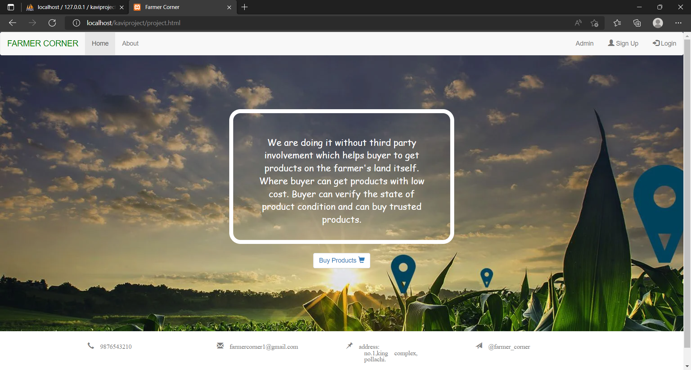

**USER REGISTRATION**

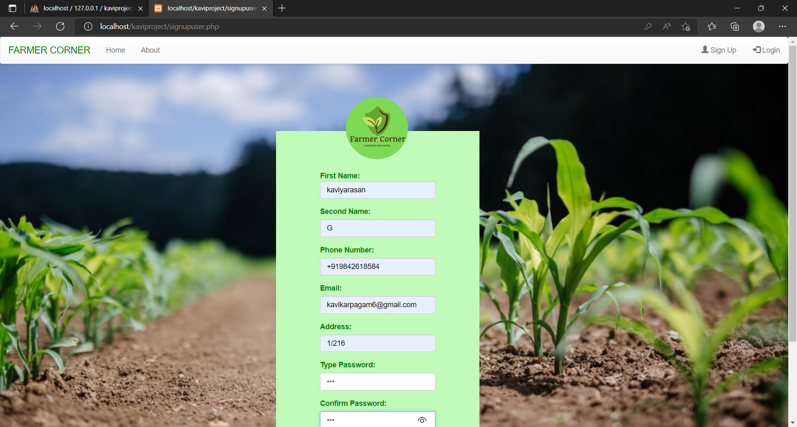

**USER LOGIN**

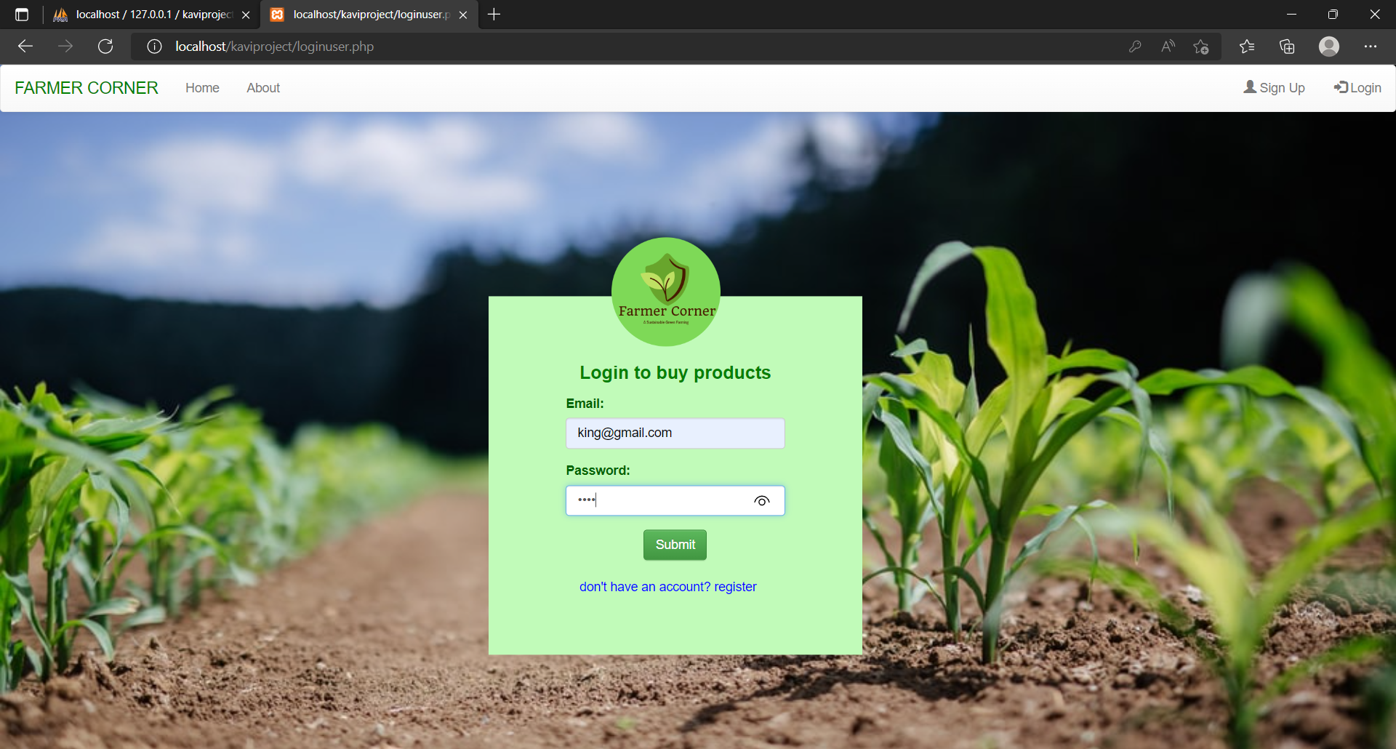

**PRODUCT PAGE**

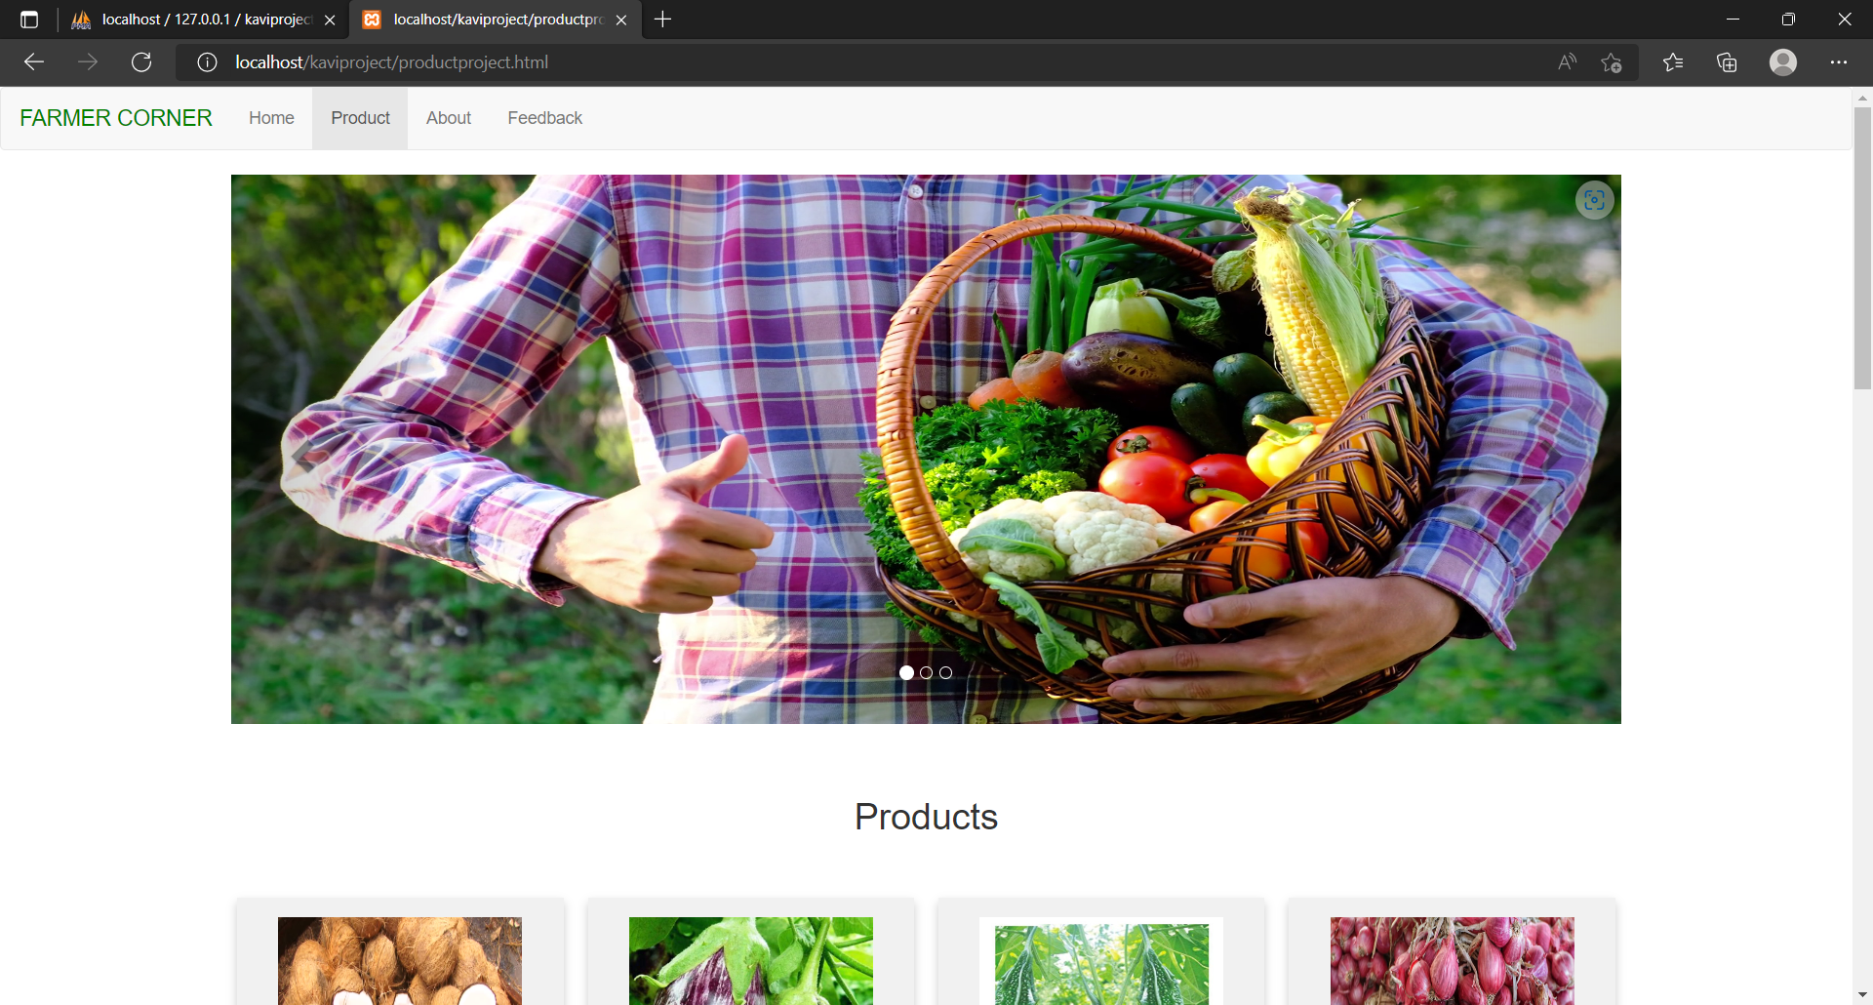

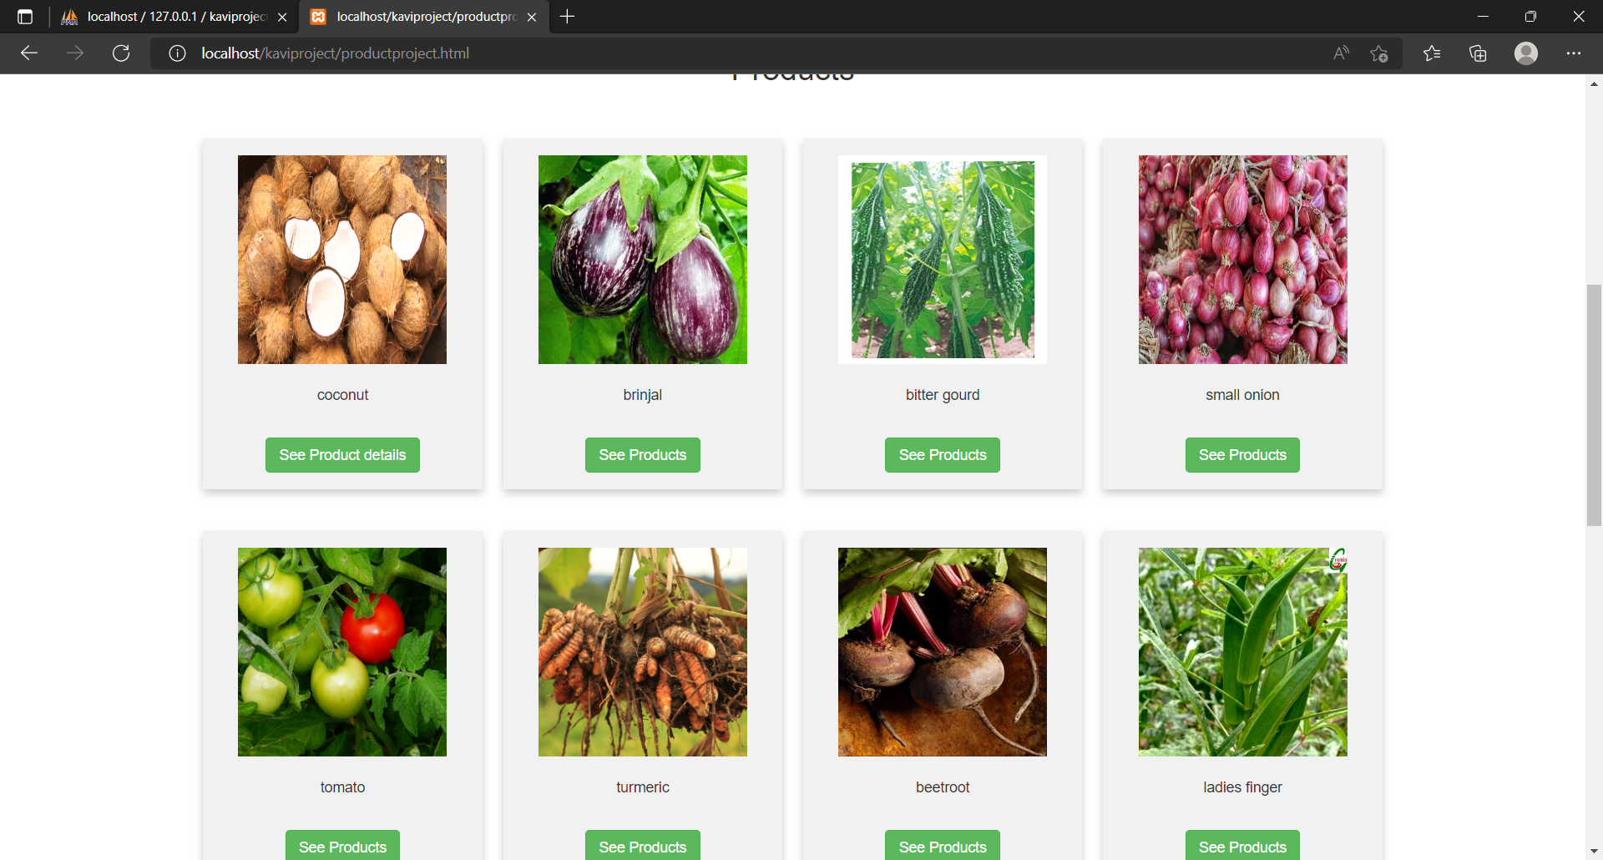

**PARTICULAR PRODUCT**

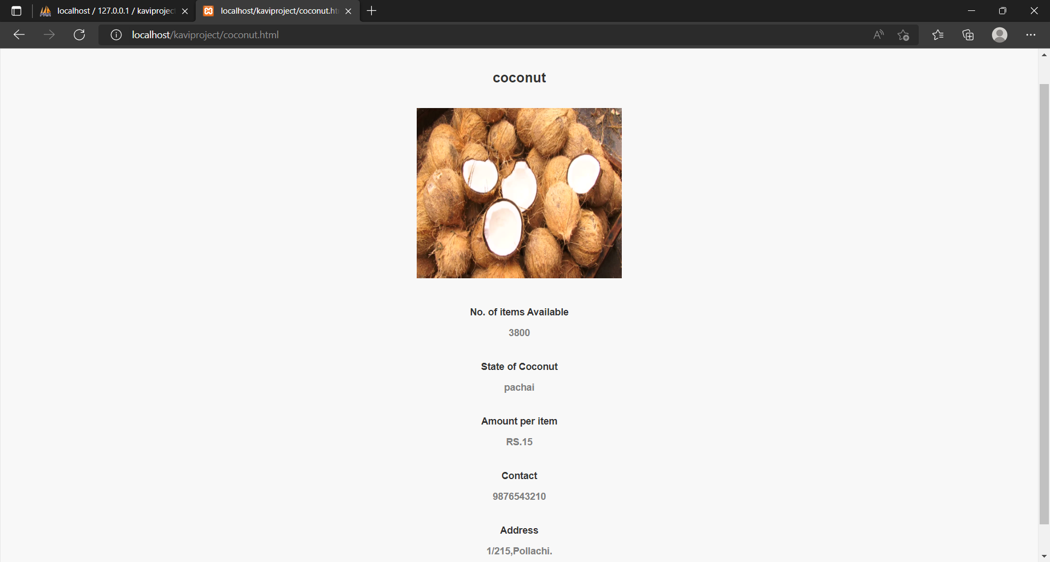

**FEEDBACK FOR USER**

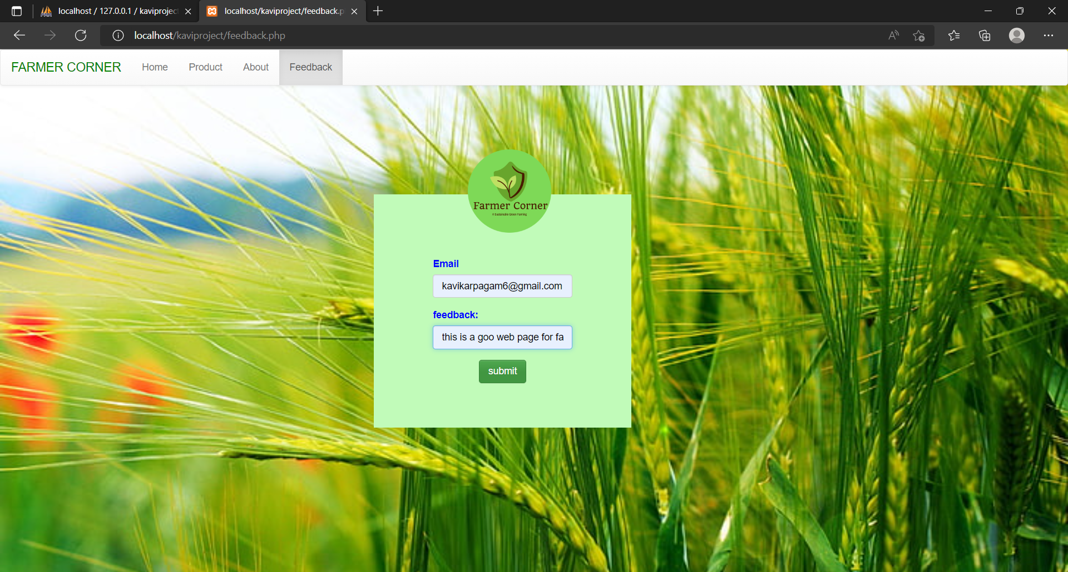

**FARMER REGISTRATION**

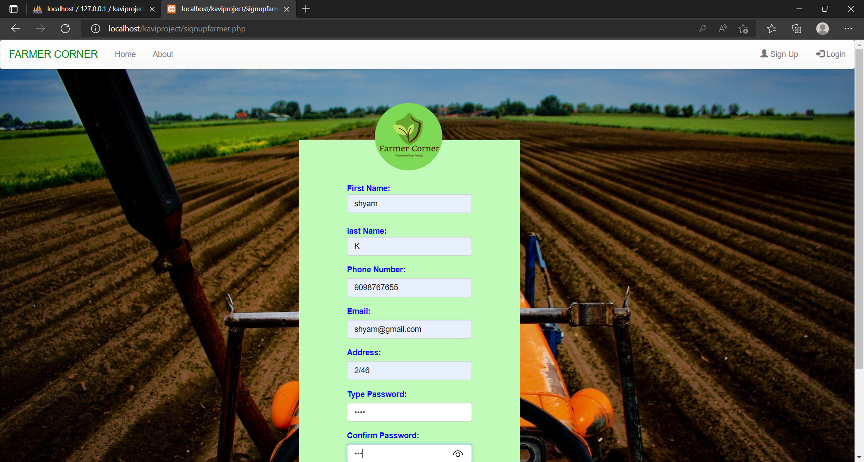

**FARMER LOGIN**

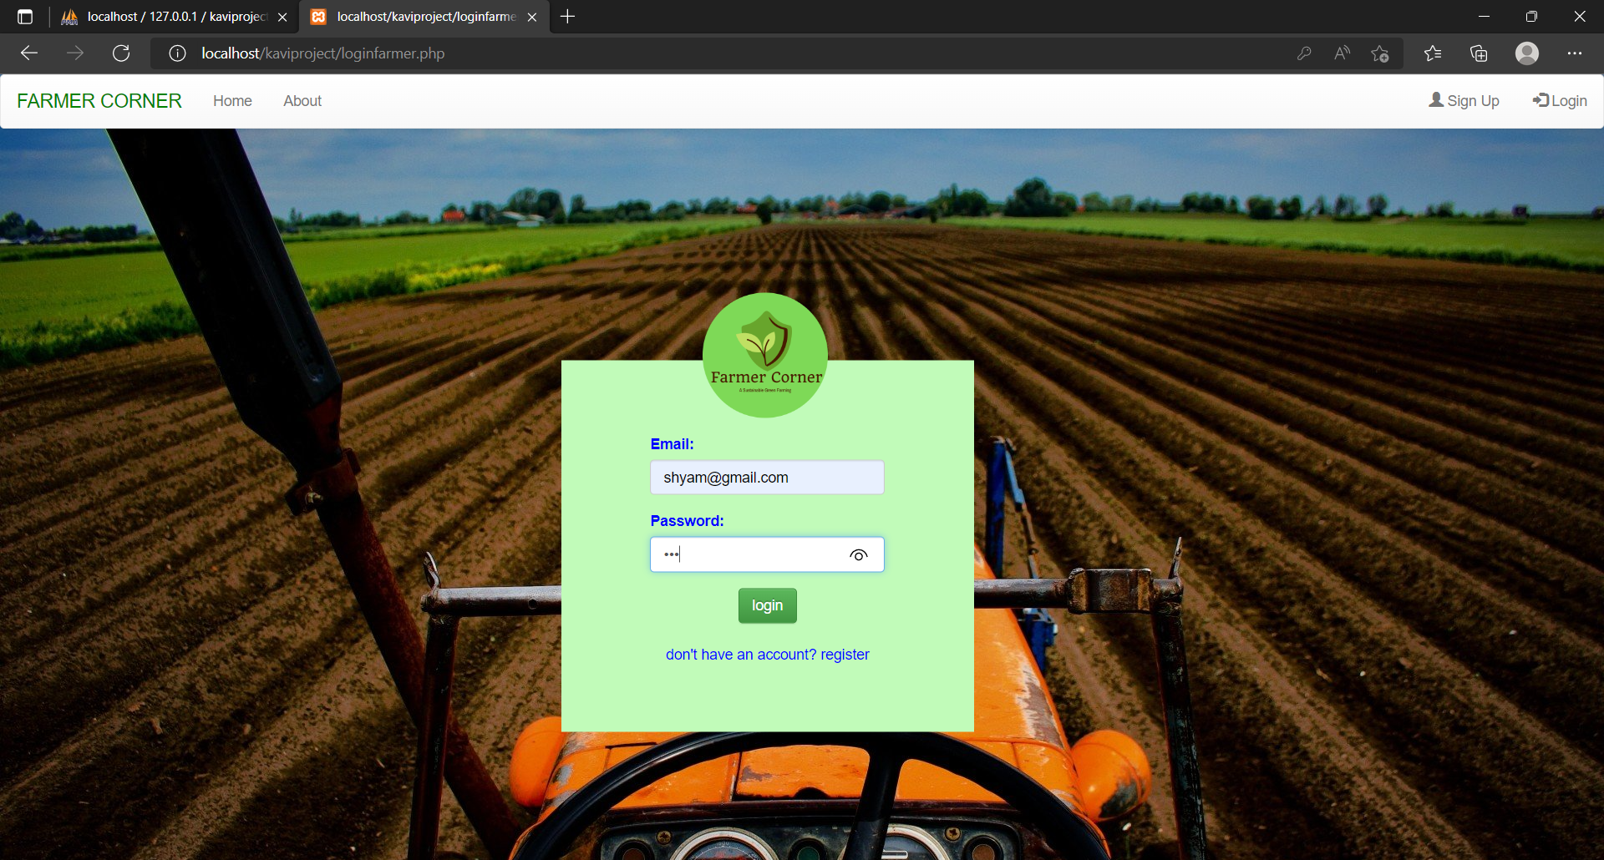

**ADMIN LOGIN**

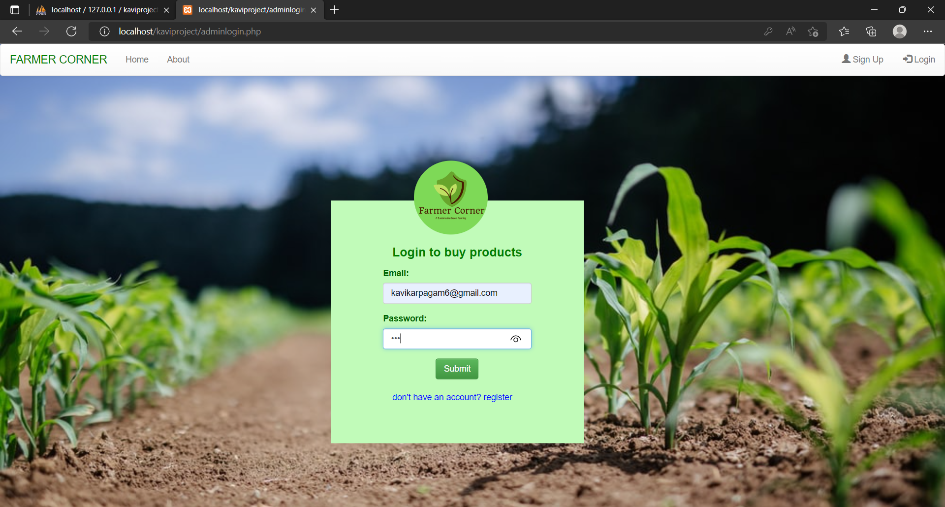

1. **REPORT**

**USER DETAILS REPORT**

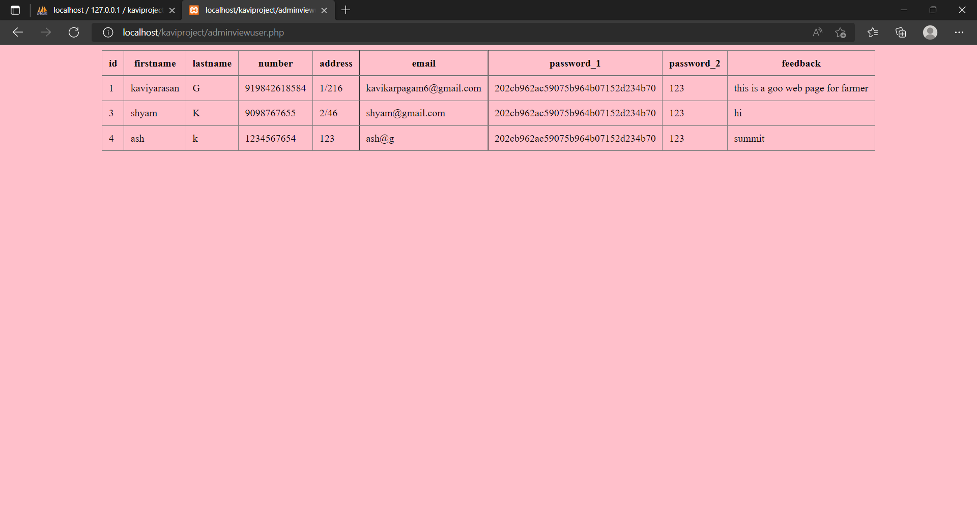

**PRODUCT DETAILS REPORT**

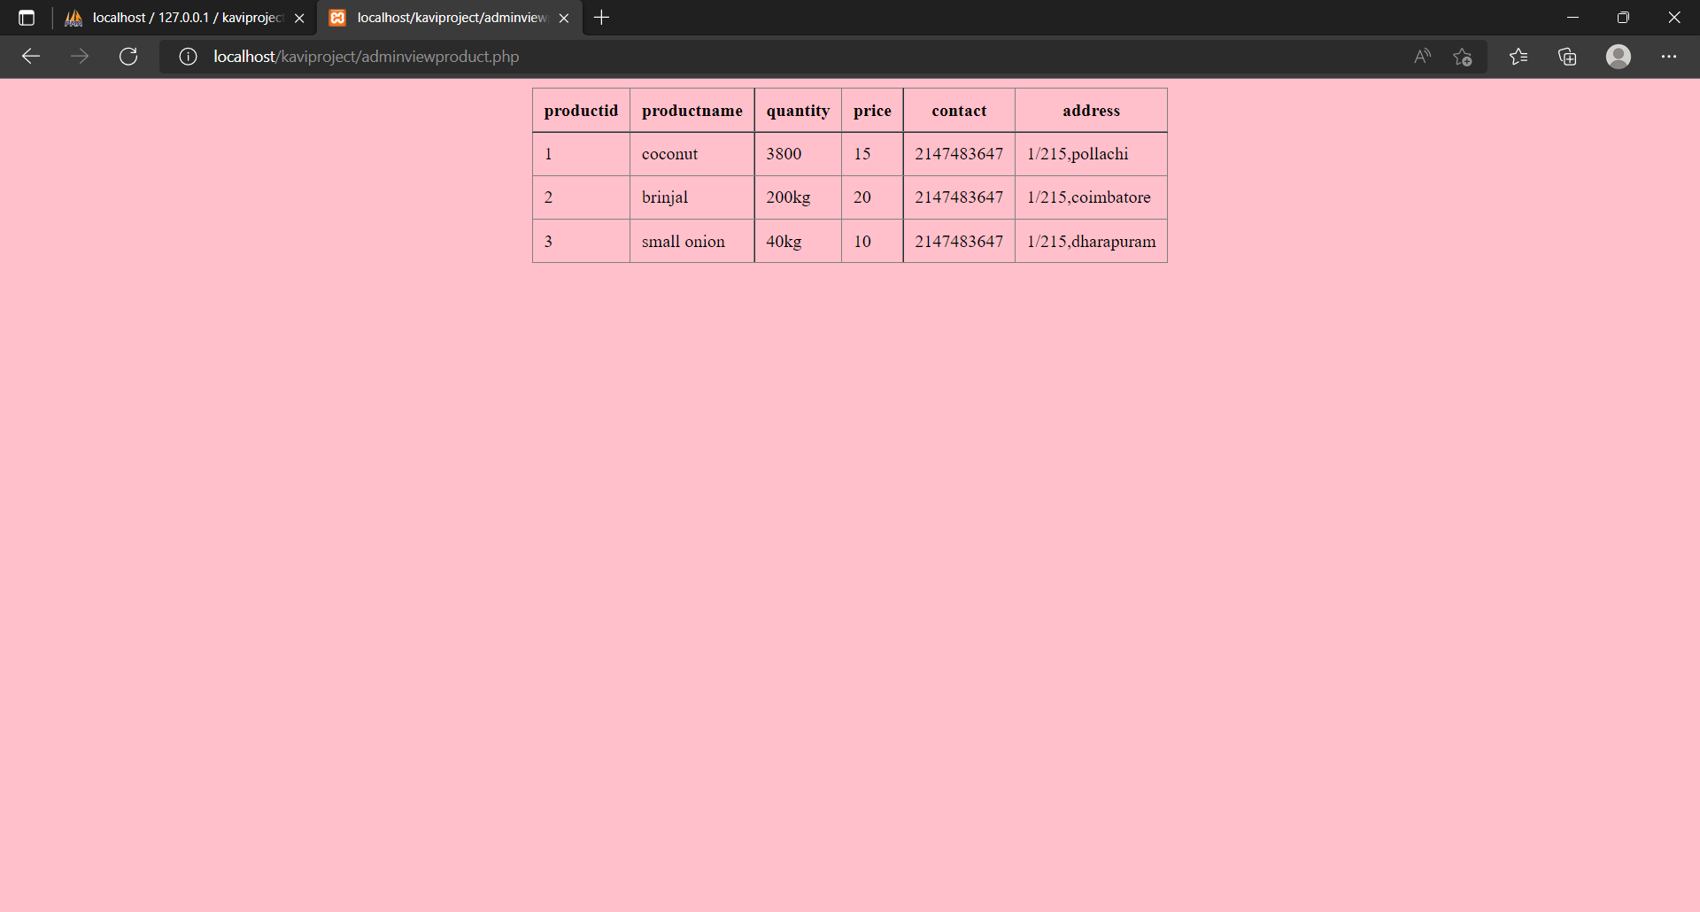

**FARMER DETAILS REPORT**

